SHELL PROGRAMS

EXP:Find the square of given number

Program:

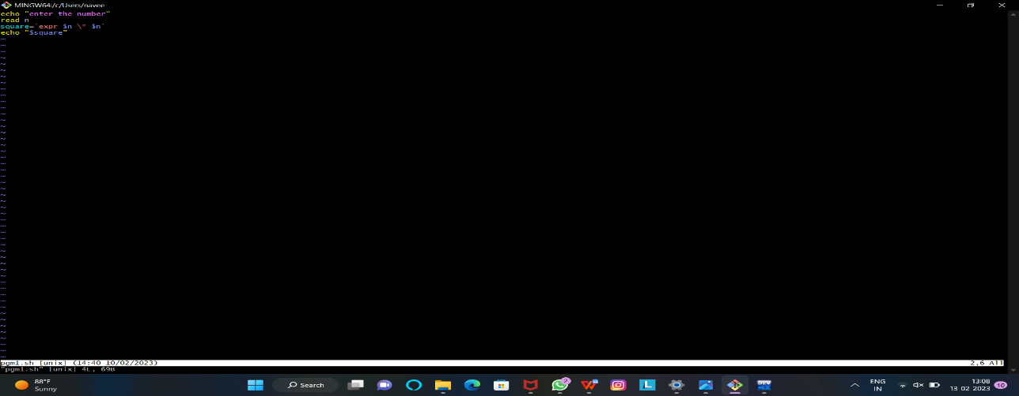

Out put:

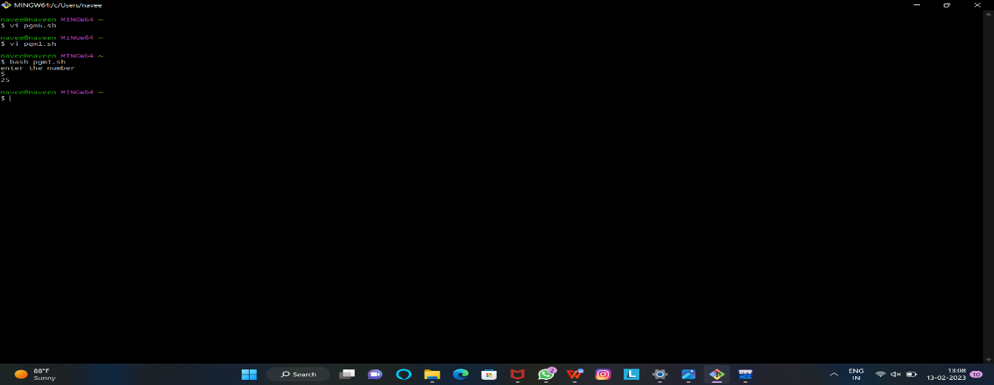

EXP: Biggest among three numbers

Program:

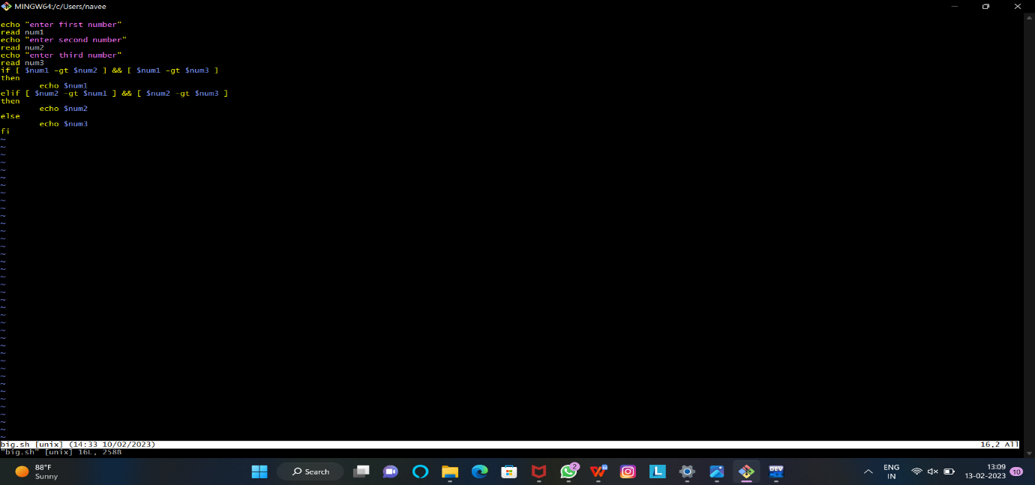

Out put:

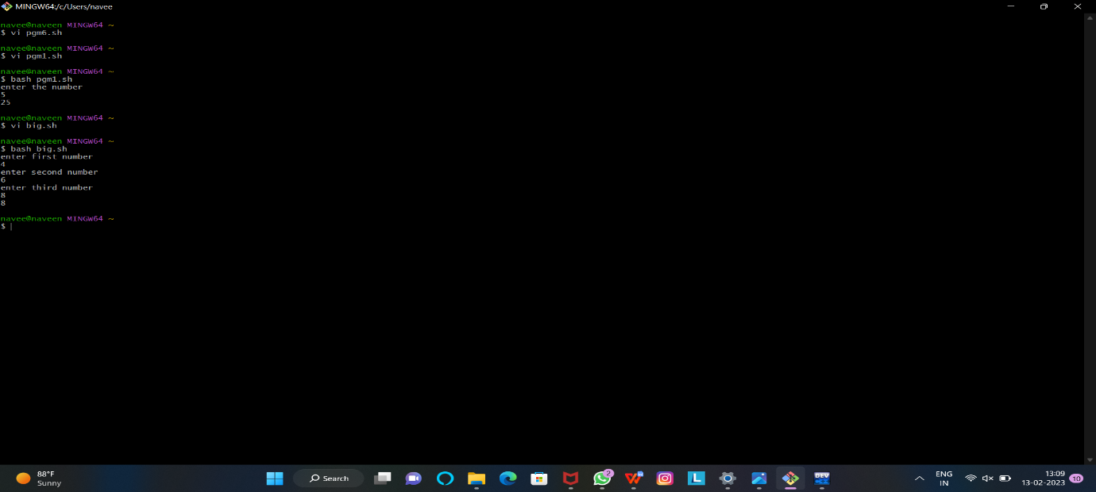

Exp: Find given year is leap year or not

Program:

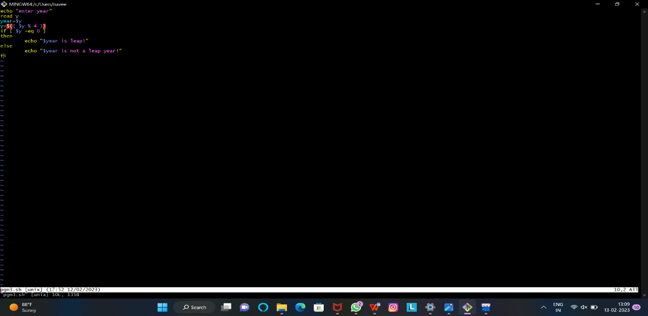

Out put:

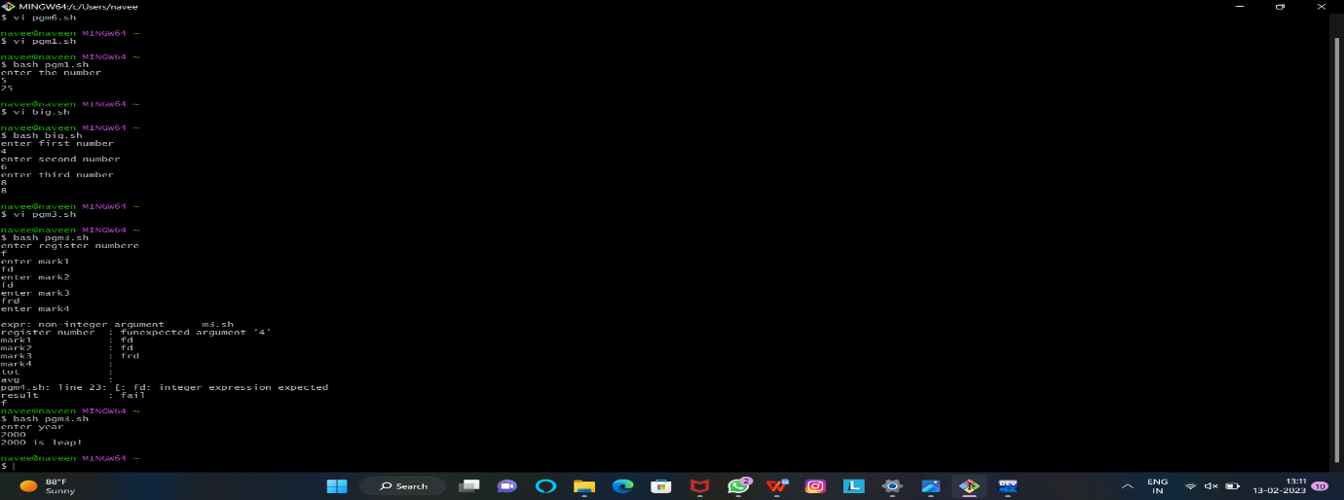

Exp: Prepare student mark list

Program:

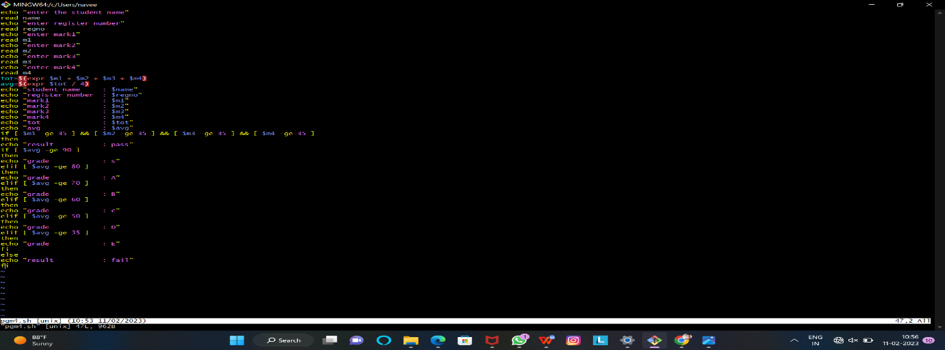

Out put:

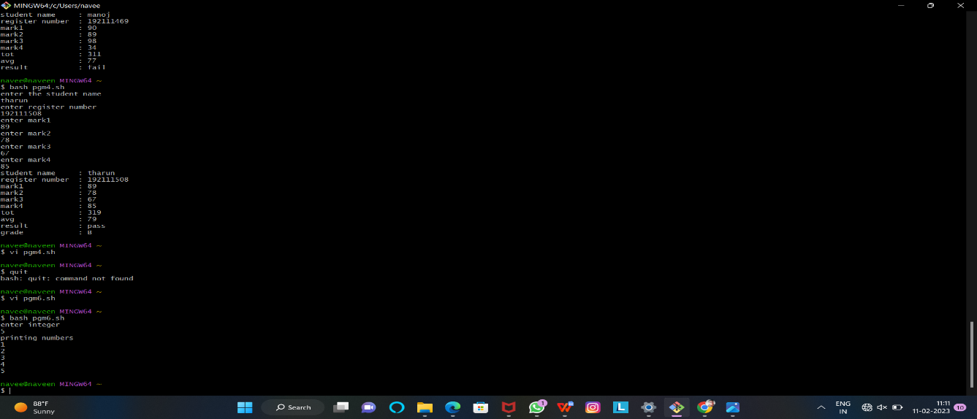

Exp: Find arithmetic operations for two numbers:

Program:

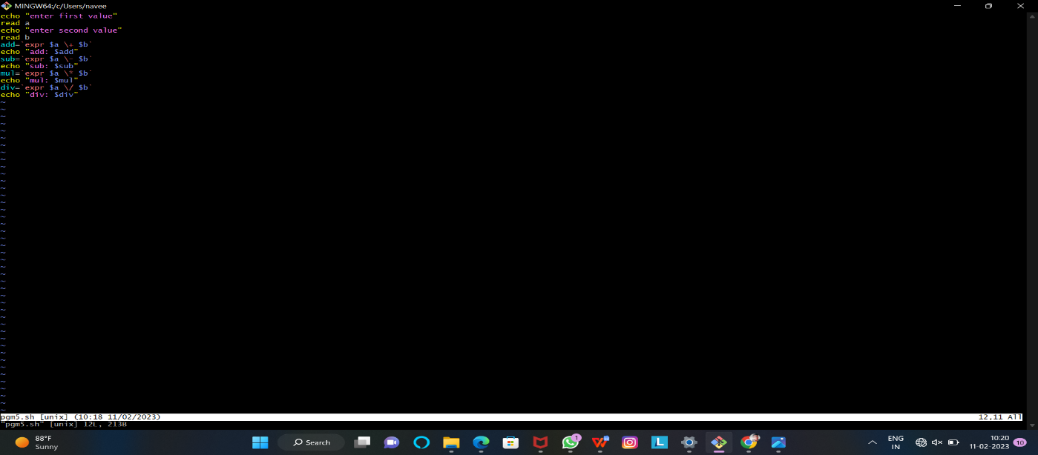

Output:

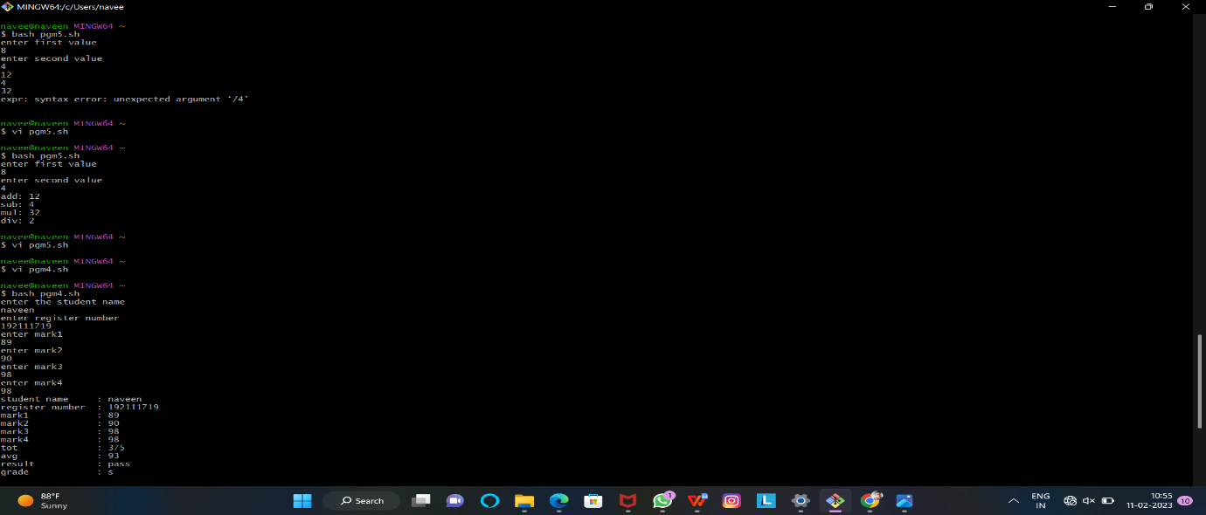

Exp: Find natural numbers from n

Program:

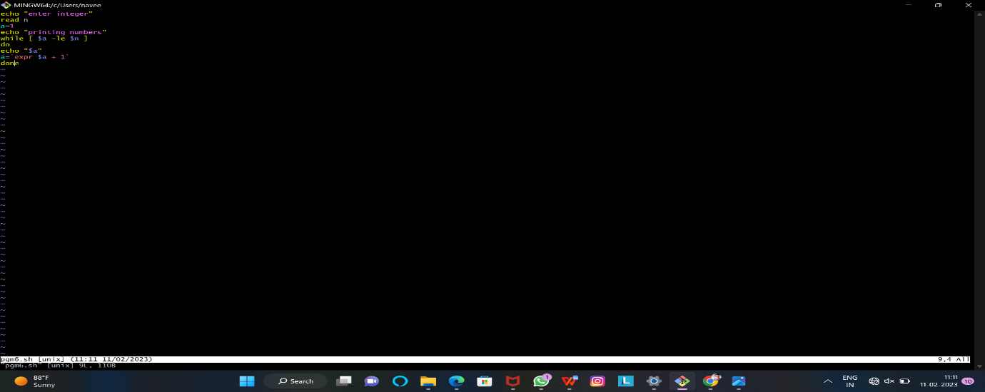

Out put:

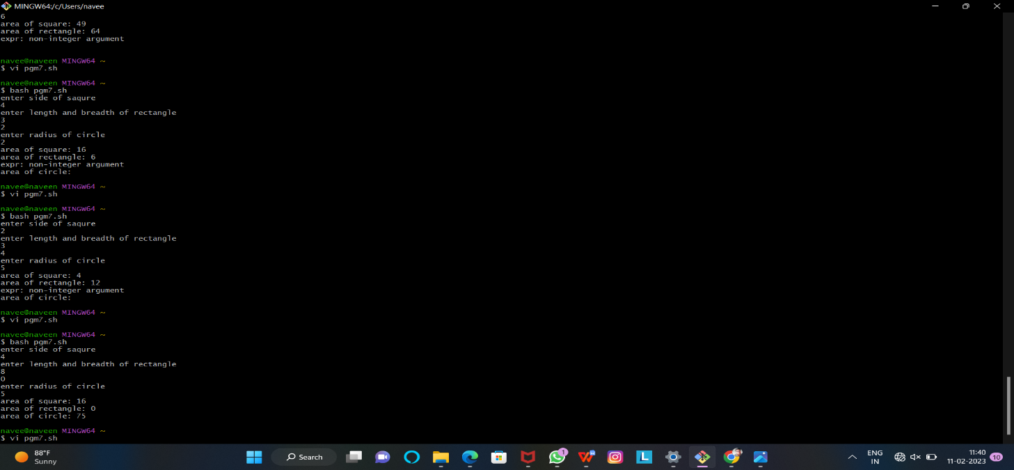

Exp:Find area of different shapes

Program:

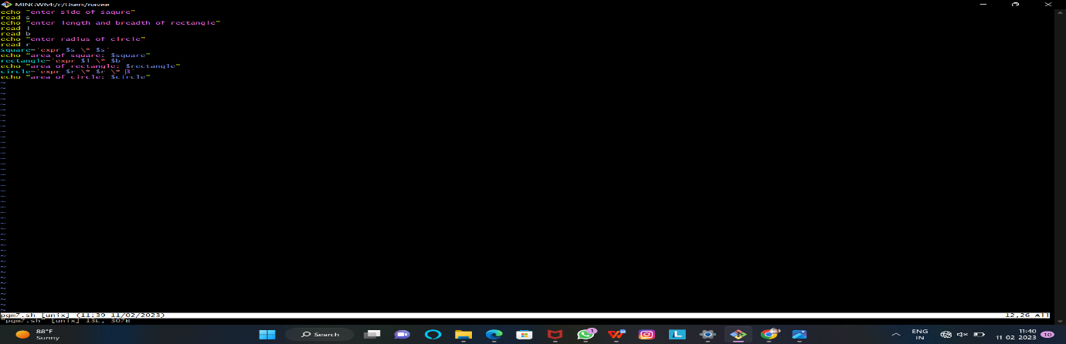

Out put:

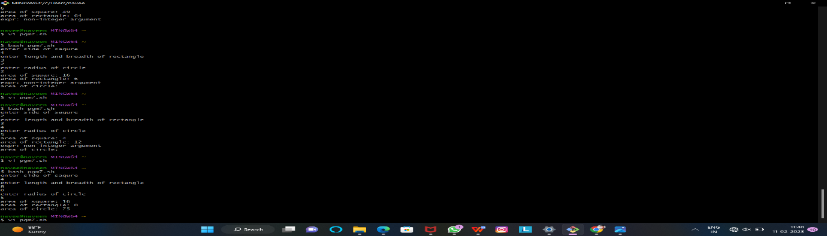

Exp: Display name , program, enrolment number:

Program:

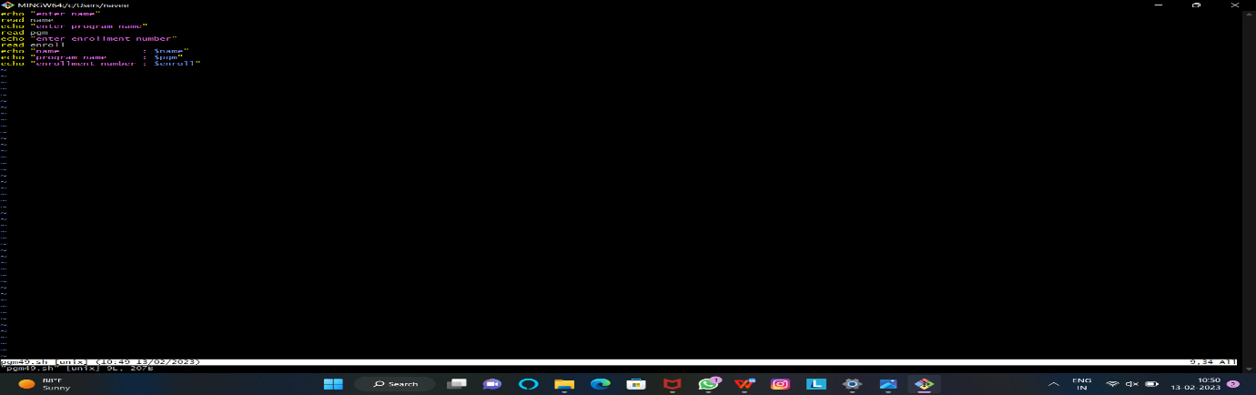

Out put:

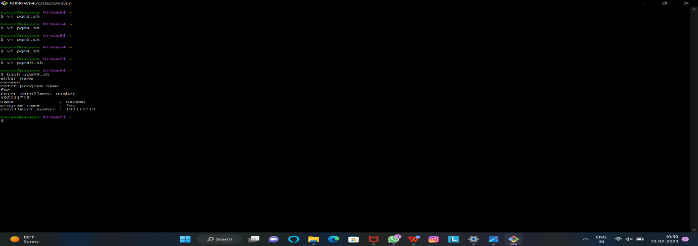

Exp : exchange two variables

Program

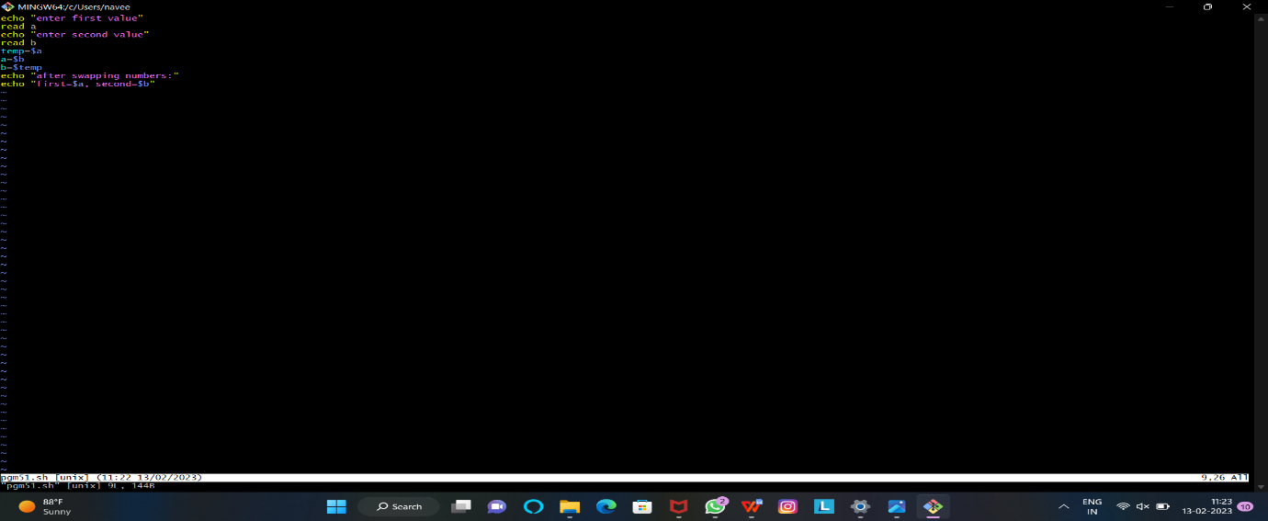

Out put:

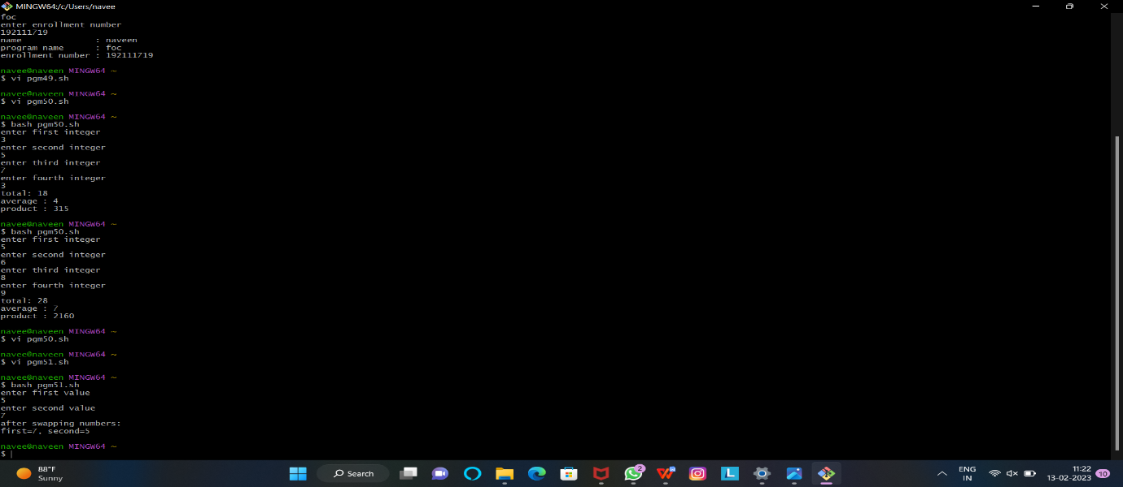

Exp: find sum, average, product of given integers

Program:

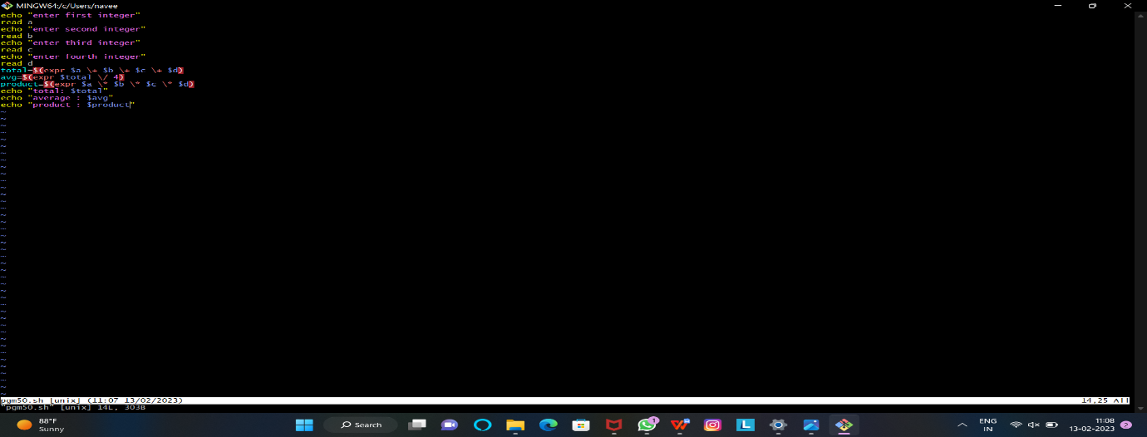

Out put:

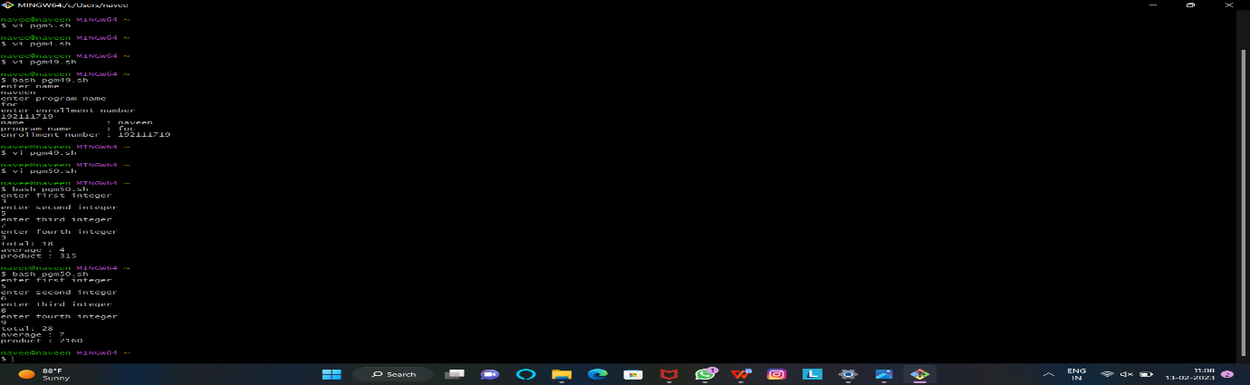

Exp: exchange two variables

Program:



Out put:

